**

**Mathematics Specialist Unit 2**

# Test 5

**Trigonometric Identities and proof**

|  |
| --- |
| **Name: ______________________ Total Marks:__________** |
|  |
|  |

**Task type: Response**

**Time allowed for this task:** 60 minutes, in-class, under test conditions

Section One: Calculator-free 37 minutes ( 35 marks)

(2 Minutes Reading – 35 Minutes Working)

Section Two: Calculator-assumed 23 minutes ( 22 marks)

(1 minutes Reading - 22 minutes working)

**Materials required:** Calculator with CAS capability (to be provided by the student)

**Standard items:** Pens (blue/black preferred), pencils (including coloured), sharpener, correction fluid/tape, eraser, ruler, highlighters

**Special items:**  Drawing instruments, templates, notes on one unfolded sheet of   
A4 paper, and up to three calculators approved for use in the WACE examinations

Formula sheet

**Marks available: 57 marks**

**Task weighting: 7%**

**Section One : Calculator Free 35 Marks**

**Time Allowed 30 minutes**

Question 1 (9 marks)

1. Express in the form where

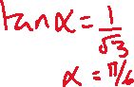

1. Hence, or otherwise solve , for



1. Sketch the graph on the grid below.

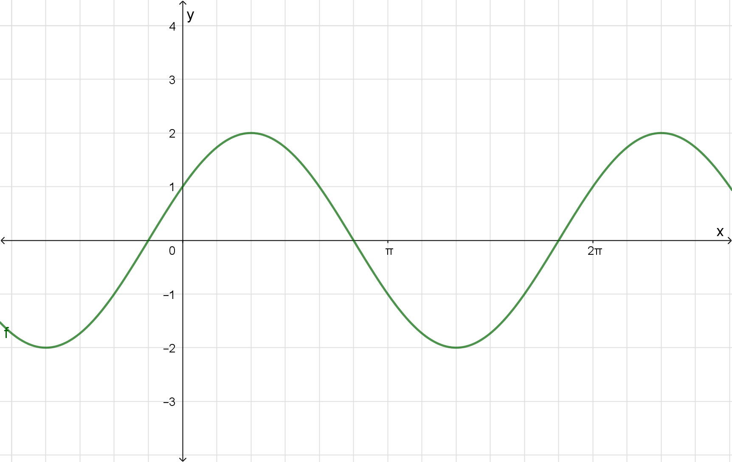



Question 2 (3 marks)

Express in exact form



Question 3 (8 marks)

1. Prove

(5 marks)



1. Solve for

(3 marks)

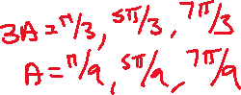

Question 4 (5 marks)

Find all the solutions to the equation



Question 5 (5 marks)

Prove by contradiction that is irrational.



Question 6 (5 marks)



Prove using mathematical Induction for all .

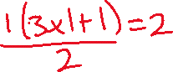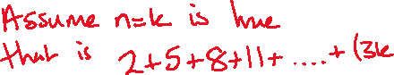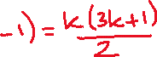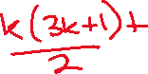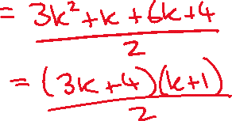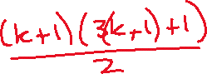

**Section Two : Calculator Assumed 22 Marks**

**Time Allowed 30 minutes Name:_______________________**

Question 7

(6 marks)

1. Show that is a rational number.

(2 marks)



1. Use algebraic reasoning to prove that the sum of the squares of two consecutive integers is odd.

(4 marks)

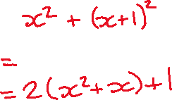

Question 8 (4 marks)

Prove that



Question 9



(5 marks)

Prove using mathematical induction that is divisible by 5 for .

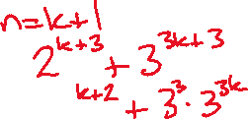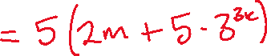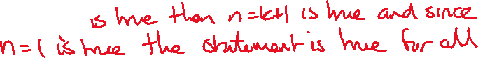

Question 10 (7 marks)



Prove the following identities

